MEADOWVALE BIBLE BAPTIST CHURCH

SUNDAY WORSHIP SERVICE

Welcome

Opening Prayer

Song: “Lord, I Lift Your Name on High”

Song: “Hosanna (Praise Is Rising)”

Song: “Open the Eyes of My Heart Lord”

Song: “Jesus Paid It All”

Kids Sunday school dismissal

Intercessory Prayer

"Prayer for Maribel’s 25th Anniversary"

Announcements

Scripture: Proverbs 15:1-16

Offering

Song: “Come Unto Jesus”

Song: “Your Name”

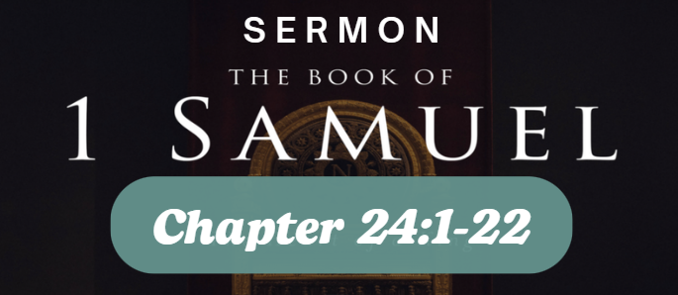

Song: “Jesus Messiah”

Closing Prayer

ANNOUNCEMENTS

The Men’s and Ladies’ Ministry is on summer break. see you all back on Saturday, September 27th!!!

MBBC Scooters (18 months – 4 years) Nursery is open in room 106. Children will sit with their parents in church until they are dismissed after the fourth song.

MBBC Scooters (18 months – 4 years) Nursery is open in room 106. Children will sit with their parents in church until they are dismissed after the intercessory prayer.

UPCOMING EVENTS

Vacation Bible School  JK- Grade 6 | 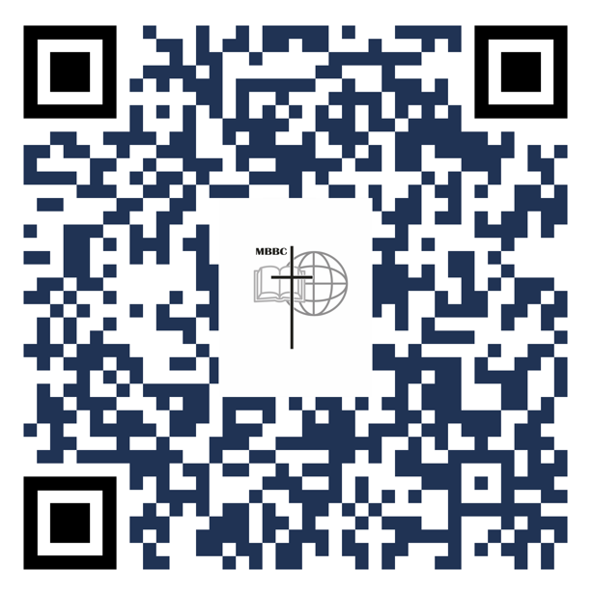  IN THE WILD  July 28th – August 1st  9am – 12pm  Register Now!!
Baptism Sunday | August 10, 11 AM  Ready to take the next step? Talk to Pastor Kennedy or a Church leader to get baptized!

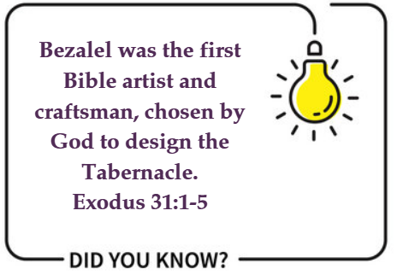

THIS WEEK
Sunday | 10:00 am | Adult Sunday School in person and ZOOM.  Passcode: 331000  Telephone: 1-647- 558-0588  Click here for zoom link
Wednesday | 7:30 pm | Mid Week Bible Study only on ZOOM  Luke 20:1-26  Meeting ID: 898 1724 7971 Passcode: 659580  Telephone: 1-647- 558-0588

SERMON NOTES

Tithing and offering
Ways to Give | 1)The e-mail address is: e-transfer@mcalearn.com In the body of the message state your full name and clearly indicate if any portion(s) of the amount are to go to designated funds  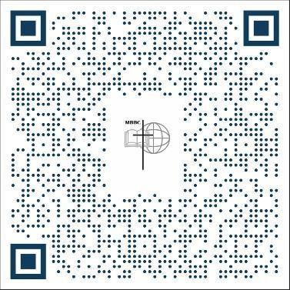  2)Scan the QR Code, a new way to give and set up monthly giving online

Sunday, July 20, 2025
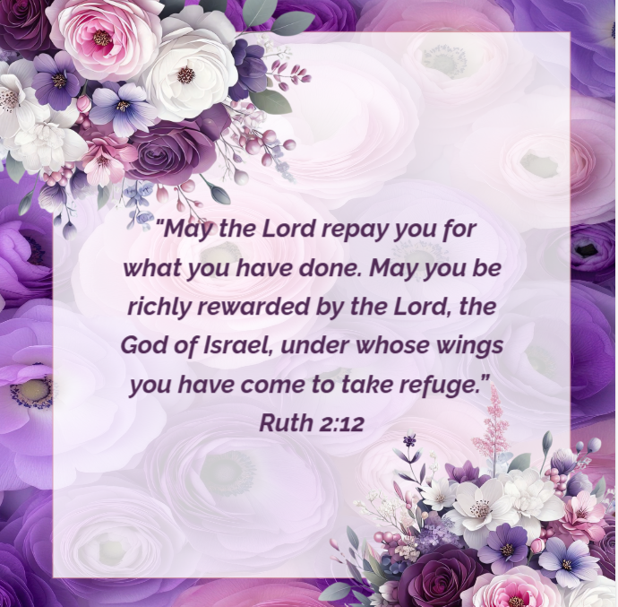

Meadowvale Bible Baptist Church

2720 Gananoque Drive • Mississauga • ON • L5N 2R2
Phone: 905-826-4114

Rev. Kelvin Kennedy, Pastor
Email: kkennedy@mbbc.ca

Mr. Kevin Yee, Mississauga Christian Academy Principal
Email: kyee@mcalearn.com

Mr. David Flores, Director of Worship
Email: dflores@mbbc.ca

Mrs. Kimberly Santineer, Administrator
Email: ksantineer@mbbc.ca

Church Website
mbbc.ca

Wi-Fi: mcaguest
Password: MCAGu3st!

